Istraživanje haosa u Čua oscilatoru

J. Janjatović

Sadržaj – U radu je analizirana pojava haosa u Čua oscilatoru. Postojanje haosa dokazano je kvalitativnim, kvantitativnim i eksperimentalnim pokazateljima determinističkog haosa. Ovim radom objašnjeno je ponašanje haosa u najjednostavnijem kolu koje je potrebno za stvaranje istog, a korišćene metode se mogu koristiti i za proučavanje haosa u složenijim električnim sistemima.

I. Manuscript Submission

The information on deadline for the receipt of camera-ready manuscripts for the current issue of IEEESTEC Student’s Conference Proceedings can be found at conference web page (http://ieee.elfak.ni.ac.rs). The contributed papers must not exceed four pages (including illustrations, tables and references). An even number of pages is preferred.
Authors are requested to submit a softcopy in both MS Word, Office 2003 version, and PDF or PostScript file format, via e-mail (danijel.dankovic@elfak.ni.ac.rs). An alternative is to send CD ROM to IEEESTEC Studnet’s Conference Secretariat.

II. Manuscript Layout

The manuscripts must be prepared using A4 paper size (210×297mm), with the text area of 174×234 mm and the margins as given in Table I. The title and authors should span the entire page width, while the main portion of the text (starting with an Abstract) should be formatted in two equal-width columns justified at both left and right- hand sides (full justification). The authors’ names should appear one blank line (10 pt) below the title, while two blank lines should be inserted between the author line and main text. The authors’ affiliations should be placed at the bottom of the first page left column within the main text area, as given below. The affiliation should contain the name and address of institution, including author’s e-mail address. Please do not specify the phone and fax numbers.

TABLE I
Text layout description

Paper size | A4
Left margin | 18 mm
Right margin | 18 mm
Top margin | 20 mm
Bottom margin | 43 mm
Column spacing | 5 mm

The column heights should be approximately equal in each page, and this can be achieved by adjusting the width of blank space between the text and section titles, figures, tables, and/or equations (the width of this blank space is, thus, not limited strictly to 10 pt). If the text does not fill the last manuscript page completely, the columns should be adjusted to approximately same heights, which can be done either by inserting the column brake (continuous type) at the end of the document or by manual insertion of blank lines at appropriate position in the left column.
This write-up is not a template, but it has been intentionally formatted to appear in the way a camera-ready manuscript should actually look like. Therefore, authors familiar with MS Word may use this document as a template, but certain modifications and re-adjustments are certainly needed. The additional problem is that this document may appear different when transferred to other PCs and/or printed out, and one can be sure that proper layout can be seen only in its PDF version, which is also part of the author’s kit. The print quality on our printer is set at moderate resolution (600 dpi), and the authors are advised to set the same print quality in their documents even though most of the printers allow for better resolution.
J. Janjatović, učenica četvrte godine Šabačke gimnazije, Masarikova 13, 15000 Šabac, Srbija. Polaznica Istraživačke stanice Petnica. E-mail: jovana.janjatovic.05@gmail.com

A. Fonts and Font Size

It is highly recommended to use the Times New Roman font for all lettering in camera-ready manuscript. Font size for the title must be 22 point (regular, not bold), with capital for the first letter of each word except articles, prepositions and conjunctions. Font size is 14 point for the author names, 10 point for the main text, 12 point for the section titles, 10 point (italic) for the subsection titles, and 9 point for the abstract, affiliations, figure & table captions, and list of references. The “small capitals” option in Format-Font menu should be used for the section titles.

B. Sectioning

All the sections should be numbered consequtively by Roman numerals starting with, e.g., “I. Introduction”, except for the “Acknowledgements” and “References”, which should not be given a section number. The subsection numbering should be done by capital letters (A, B, ...). The section titles should be centred, while the titles of subsections should begin from the left hand side of the column. Both section and subsection titles should be separated from the text by a blank line (above and below the title).

C. Equations

Equations should appear in a separate line from the text with a blank line above and below. The equation number should appear in round parentheses and flush with the right margin, as shown in the example of Eq. 1:

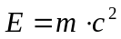 (1)

Long equations can be split across multiple lines, as shown in the example of Eq. 2:

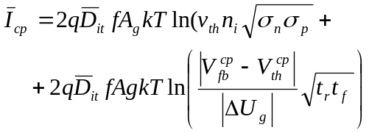 (2)

D. Figures and Tables

All illustrations (graphs, tables and photographs) should be specified in numerical order in the text and must have captions. Figures and tables should preferably occupy the width of one column. Large figures and tables may span both columns but should be within the typing area of each page. The proceedings will be printed black & white, and the authors are kindly advised to avoid the excessive usage of coloured illustrations and/or fonts. The photographs also should be black & white high-contrast originals.
Figure captions should be placed below the figures while table captions should be placed above the tables. As can be seen in examples of Fig. 1 and Table I, Arabic numerals should be used for the figures and Roman numerals for the tables. A blank line should be inserted between the text and the tables or figures.

E. Citations and Bibliography

When referring to the references in the text, the reference number should be designated by square brackets, for example [1], [2], [3]-[5]. Please list and number all references after the “Conclusion” section following the order of their appearance in the text, and make sure to use the appropriate format for referencing a journal paper, a proceedings paper, a book, or a paper/chapter from the book, according to the IEEE Transactions format. The examples for different reference formats are given at the end of this write-up.

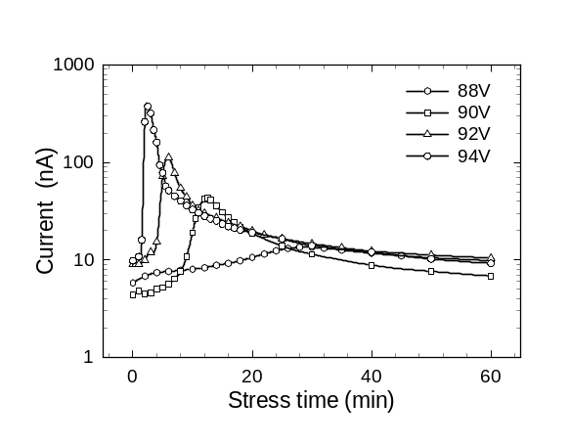

Fig. 1. This is an example of the figure caption which must come after the figure.

III. Conclusion

The instructions for preparing the camera-ready manuscripts for publication in the current issue of the MIEL Conference Proceedings have been given. The authors of both contributed and keynote invited papers are kindly requested to follow the above instructions as much as possible. The final manuscripts should be emailed to danijel.dankovic@elfak.ni.ac.rs or sent by post to the following address:

IEEESTEC Student’s Conference Secretariat
EESTEC LC NIŠ
Faculty of Electronic Engineering
University of Niš
Aleksandra Medvedeva 14, 18000 Niš
SERBIA

E-mail:danijel.dankovic@elfak.ni.ac.rs
http://ieee.elfak.ni.ac.rs

Acknowledgement

Acknowledgements may be included in the paper by inserting a separate section after the Conclusion and before the References.
References

[1] N. Stojadinovic, S. Djoric-Veljkovic, I. Manic, V. Davidovic, and S. Golubovic, “Effects of Elevated-Temperature Bias Stressing on Radiation Response in power VDMOSFETs”, in Proc. 8th International Symposium on the Physical & Failure Analysis of Integrated Circuits IPFA 2001, Singapore, 2001, pp. 243-248.
[2] Z. Prijic, P. Igic, Z. Pavlovic, and N. Stojadinovic, “Simple method for the extraction of power VDMOS transistor parameters”, Microelectronics Journal, 1996, vol. 27, pp. 567-570.
[3] D. J. Roulston, N. D. Arora, and S. G. Chamberlain, “Modeling and Measurement of Minority-Carrier Lifetime versus Doping in Diffused Layers of n⁺p Silicon Diodes”, IEEE Trans. Electron Devices, vol. ED-29, pp. 284-291, 1982.
[4] S. Dimitrijev, Understanding the Semiconductor Devices, New York, Oxford: Oxford University Press, 2000.
[5] T. Grasser, V. Palankovski, G. Schrom, and S. Selberherr, “Hydrodynamic Mixed-Mode Simulation”, in Simulation of Semiconductor Processes and Devices, K. De Meyer and S. Biesemans, Eds., pp. 247-250, Wien, New York: Springer, 1998.

